INFORMATION TECHNOLOGY INSTITUTE
Analog IC Design Track

Analog Integrated Circuit Design
Lab 10
Noise Simulation

Table of Contents
PART 1: Feedback with Behavioral OTA 3
1.1 Closed-Loop Gain vs. Frequency 4
1.1.1 Simulation Results: 4
1.1.2 Hand Analysis: 5
1.2 Loop gain vs frequency (STB Analysis): 6
1.2.1 Simulation Results: 6
1.2.2 Hand Analysis: 7
1.3 Gain Desensitization: 9
1.3.1 Simulation Results: 9
1.3.2 Hand Analysis: 10
2 PART 2: Feedback with Real 5T OTA 11
2.1 Closed-Loop Gain vs. Frequency 11
2.1.1 Simulation Results: 11
2.2 Loop gain vs frequency (STB Analysis): 13
2.2.1 Simulation Results: 13
2.3 Gain Desensitization: 14
2.3.1 Simulation Results: 14
2.4 Transient analysis: 16
2.4.1 Simulation Results at $FIN=1$ kHz: 16
2.4.2 Simulation Results at $FIN=BWCL$ ($1.773$ MHz): 18

PART 1: LPF AC Noise Analysis
  - Output Noise vs. Frequency
    - Simulation Results:
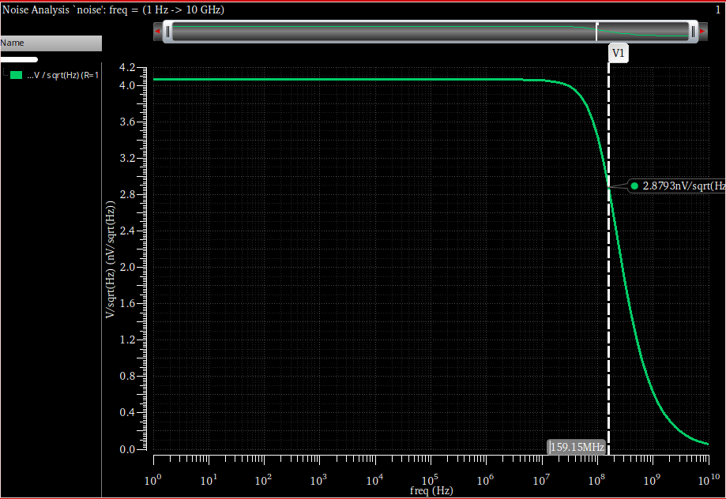
Figure 1: output voltage noise spectral density vs frequency for LPF ($R=1\text{ k}Ω$, $C=1\text{ pF}$)
As we see
Low-Frequency Voltage Noise Density: $4.07\text{ nV}/\sqrt{\text{Hz}}$
Bandwidth: $159.15\text{ MHz}$
    - Hand Analysis:
Thermal Noise Density:
The input-referred thermal noise generated by the resistor is given by:
$$v_{n}=\sqrt{4kTR}$$
$$v_{n}=\sqrt{4×\left(1.38×{10}^{-23}\right)×300×1000}≈4.07\text{ nV}/\sqrt{\text{Hz}}$$
Bandwidth:
$$f_{3dB}=\frac{1}{2πRC}$$
$$f_{3dB}=\frac{1}{2π\left(1000\right)\left({10}^{-12}\right)}≈159.15\text{ MHz}$$

Total RMS Noise ($v_{n,rms}$):
$$v_{n,rms}=\sqrt{\frac{kT}{C}}$$
$$v_{n,rms}=\sqrt{\frac{1.38×{10}^{-23}×300}{{10}^{-12}}}≈64.34 μ\text{V}$$
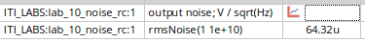
Figure 2: total RMS noise
Table 1: Comparison Table:
Parameter | Hand Calc. | Simulation
Noise Density | $$4.07\text{ nV}/\sqrt{\text{Hz}}$$ | $$4.071\text{ nV}/\sqrt{\text{Hz}}$$
BW | $$159.15\text{ MHz}$$ | $$159.15\text{ MHz}$$
Total RMS | $$64.34 μ\text{V}$$ | $$64.32 μ\text{V}$$

  - Parametric Sweep
    - Simulation Results:
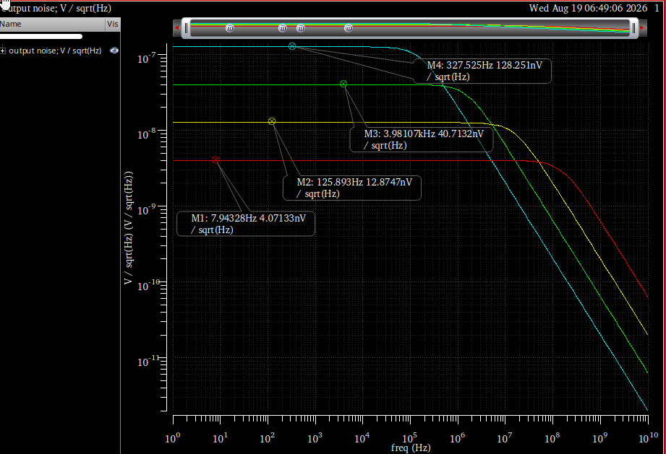
Figure 3: Overlaid AC output noise spectral density plots for $R=1\text{k}Ω,10\text{k}Ω,100\text{k}Ω,\text{ and }1\text{M}Ω$
$R=1\text{ k}Ω$: $≈4.07\text{ nV}/\sqrt{\text{Hz}}$
$R=10\text{ k}Ω$: $≈12.87\text{ nV}/\sqrt{\text{Hz}}$
$R=100\text{ k}Ω$: $≈40.71\text{ nV}/\sqrt{\text{Hz}}$
$R=1\text{ M}Ω$: $≈128.25\text{ nV}/\sqrt{\text{Hz}}$
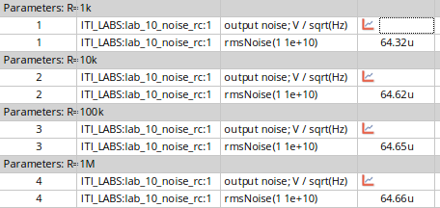
Figure 4: total RMS output noise for varying $R$
the total thermal noise of a simple RC circuit is independent of the resistance. Although a larger resistor generates a higher thermal noise spectral density ($∝\sqrt{R}$), it proportionally restricts the noise bandwidth ($∝1/R$). During integration, the resistance terms cancel out, leaving the total noise voltage entirely constrained by the load capacitance ($v_{n,rms}=\sqrt{kT/C}$).
- PART 2: LPF Transient Noise Analysis
  - Transient Noise Analysis
    - Simulation Results:
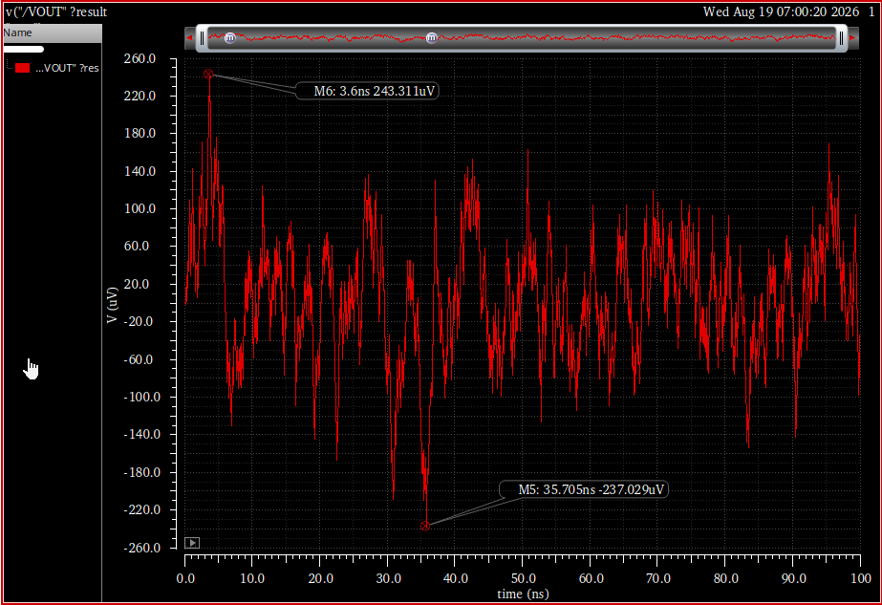
Figure 5: Transient noise output waveform
From the simulation plot:
- Maximum Value: $243.31 μ\text{V}$ at $3.6\text{ ns}$
- Minimum Value: $-237.03 μ\text{V}$ at $35.7\text{ ns}$
    - RMS Noise Comparison
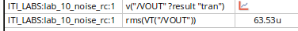
Figure 6: RMS calculation of the output noise
This value ($63.53 μ\text{V}$) is close to the AC noise RMS value obtained in Part 1 ($64.32 μ\text{V}$).
    - Effect of Time Step (TSTEP) on Noise:
The simulation was repeated with a larger time step, changing TSTEP from $\text{TAU}/100$ to $\text{TAU}/10$.
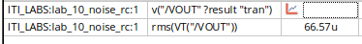
Figure 7: RMS calculation of the output noise with $\text{TSTEP}=\text{TAU}/10$.

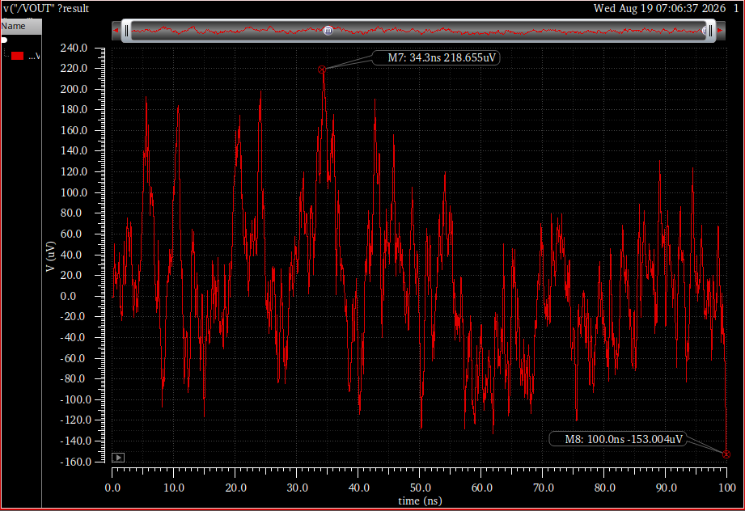
Figure 8: Transient noise output waveform with ($\text{TSTEP}=\text{TAU}/10$).
Output Noise RMS Increased Slightly as Fmax increased so the area integrated is
bigger.
    - 20 Iterations Analysis

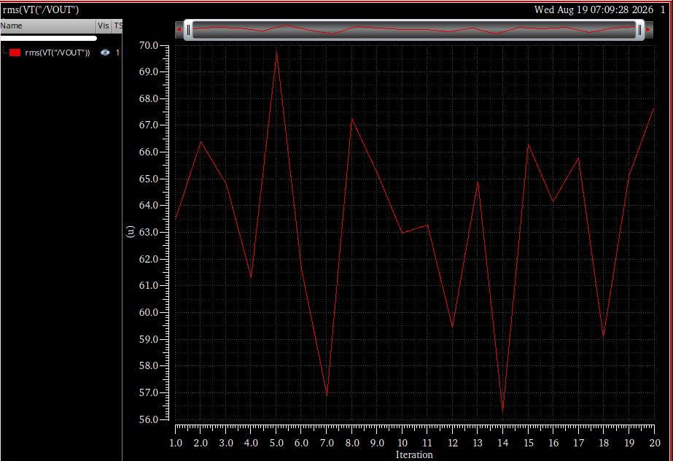
Figure 9: RMS noise versus iteration number for 20 distinct transient noise simulation

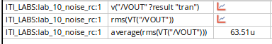
Figure 1: Average RMS Noise
The averaged transient RMS noise ($63.51 μ\text{V}$) is very closely to the AC simulation result from Part 1 ($64.32 μ\text{V}$). although individual transient noise simulations are subject to high random variance.
- PART 3: 5T OTA AC Noise Analysis
  - Thermal Noise vs. Frequency
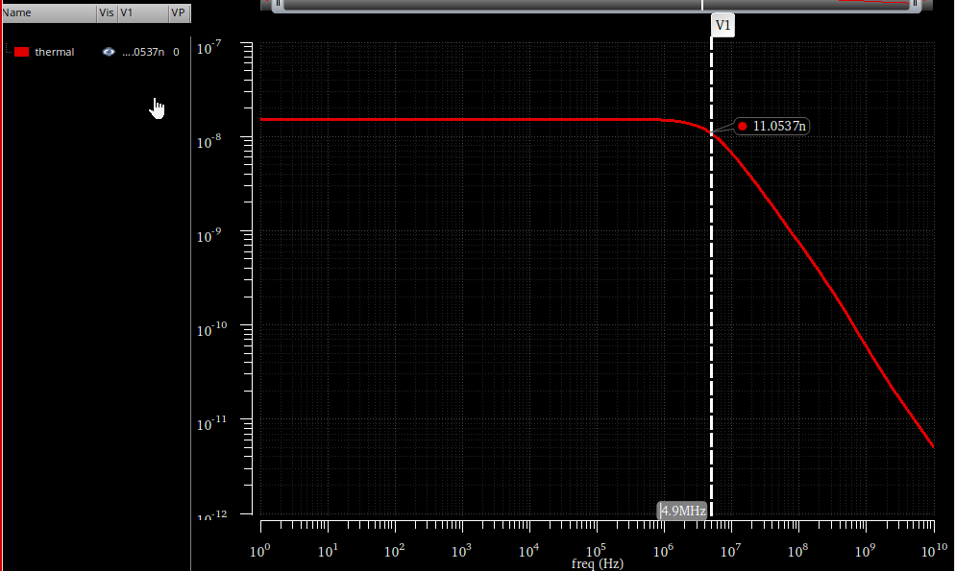
Figure 11: Thermal noise
Thermal Voltage Noise Density: $15.62\text{ nV}/\sqrt{\text{Hz}}$
Closed-Loop Bandwidth: $4.896\text{ MHz}$
  - Total Output Noise & Flicker Corner
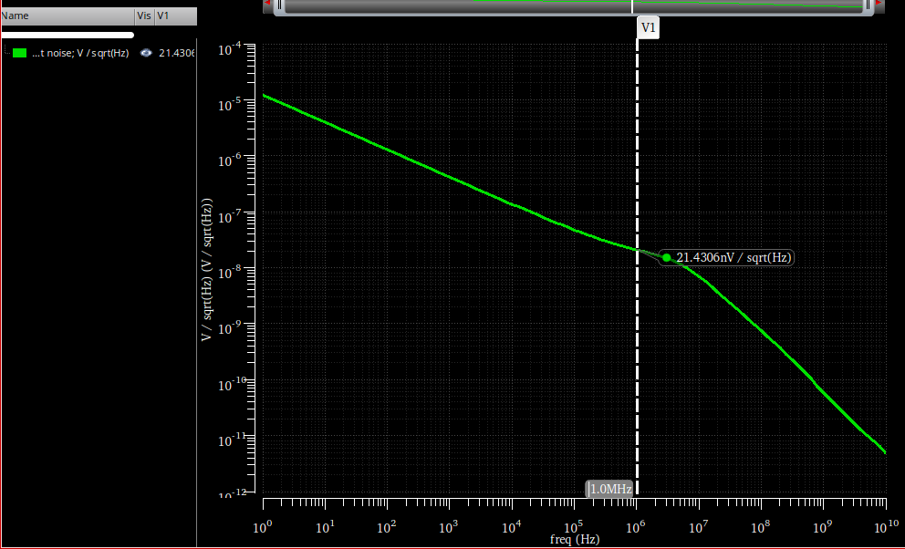
Figure 12: Total output noise spectral density in log scale
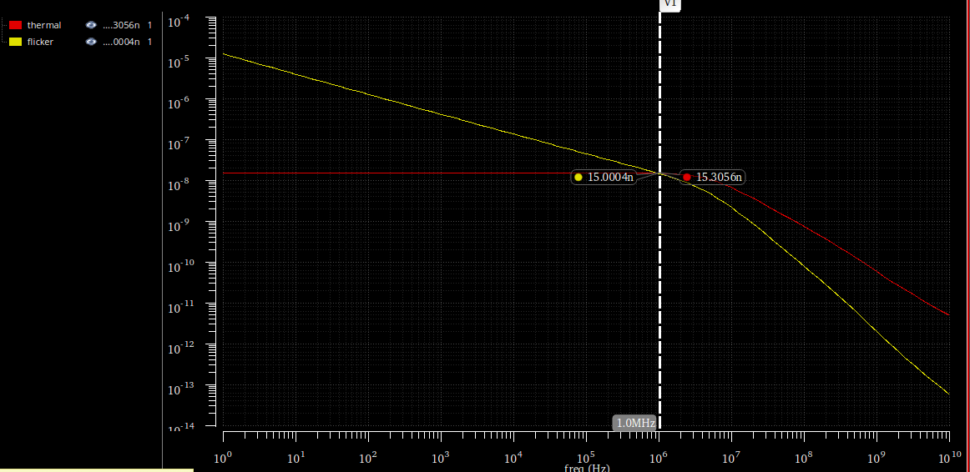
Figure 13: corner frequency
Flicker Noise Corner Frequency ($f_{c}$): $1.0\text{ MHz}$
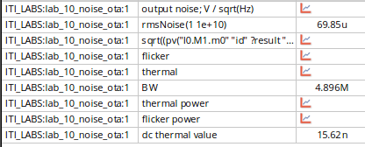
Figure 13: the total RMS noise ($69.85 μ\text{V}$), bandwidth ($4.896\text{ MHz}$), and DC thermal noise floor ($15.62\text{ nV}/\sqrt{\text{Hz}}$).
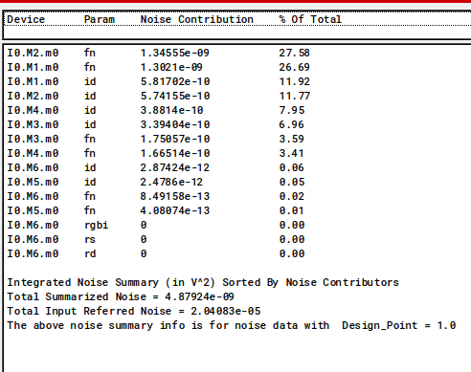
Figure 14: Integrated noise summary
Total Simulated Thermal Noise Power = $1.8887×{10}^{-9}{\text{ V}}^{2}$
Simulated RMS Thermal Noise = $\sqrt{1.8887×{10}^{-9}}=43.46 μ\text{V}$
$C_{L}=5\text{ pF}$, $g_{m1,2}=157 μ\text{A/V}$, and $g_{m3,4}=100 μ\text{A/V}$. assume $γ≈2/3$.
$$f_{3dB}≈\frac{g_{m1}}{2πC_{L}}$$
$$f_{3dB}≈\frac{157×{10}^{-6}}{2π\left(5×{10}^{-12}\right)}≈4.99\text{ MHz}$$
$$v_{n,th}=\sqrt{\frac{16kT}{3g_{m1}}\left(1+\frac{g_{m3}}{g_{m1}}\right)}$$
$$v_{n,th}=\sqrt{\frac{16\left(1.38×{10}^{-23}\right)\left(300\right)}{3\left(157×{10}^{-6}\right)}\left(1+\frac{100}{157}\right)}≈15.16\text{ nV}/\sqrt{\text{Hz}}$$
$$v_{n,rms,th}=\sqrt{v_{n,th}^{2}×NBW}=\sqrt{\frac{4kT}{3C_{L}}\left(1+\frac{g_{m3}}{g_{m1}}\right)}$$
$$v_{n,rms,th}=\sqrt{\frac{4\left(1.38×{10}^{-23}\right)\left(300\right)}{3\left(5×{10}^{-12}\right)}\left(1+\frac{100}{157}\right)}≈42.5 μ\text{V}$$

Parameter | Hand Calculation | Simulation Result
Bandwidth | $$4.99\text{ MHz}$$ | $$4.896\text{ MHz}$$
Thermal Noise Density | $$15.16\text{ nV}/\sqrt{\text{Hz}}$$ | $$15.62\text{ nV}/\sqrt{\text{Hz}}$$
Total RMS Noise | $42.5 μ\text{V}$ (Thermal Only) | $$43.46 μ\text{V}$$
- PART 4: 5T OTA Transient Noise Analysis
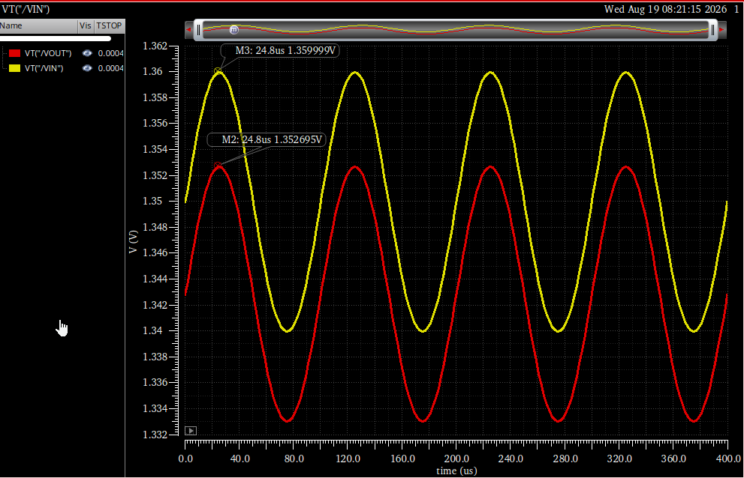
Figure 15: $10\text{ kHz}$, $10\text{ mV}$ amplitude input signal (yellow) and the resulting output signal (red) with a slight systematic DC offset
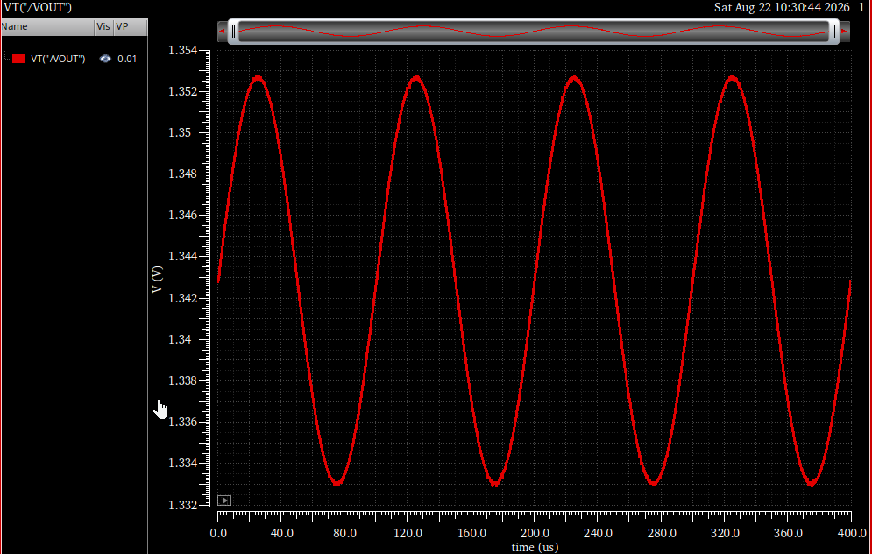
Figure 16: Full transient noisy output waveform
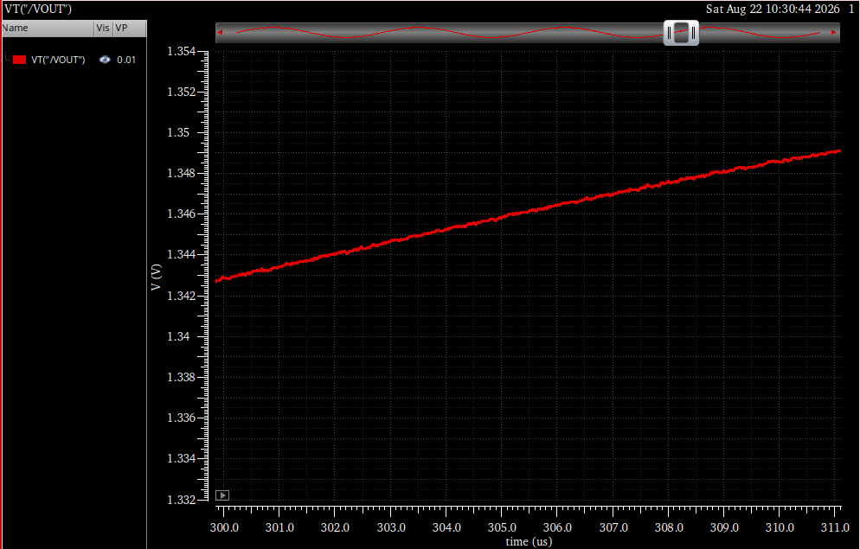
Figure 17: Zoomed-in view of the transient output
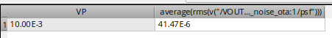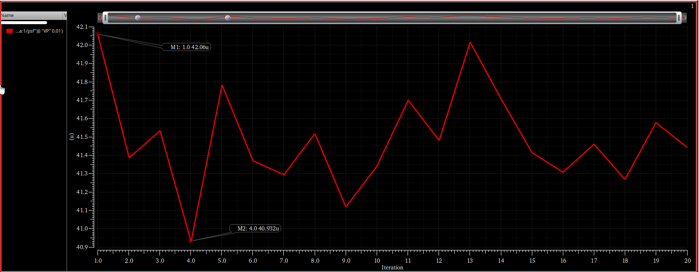
Figure 18: RMS vs iterations
From part 3 the thermal rms
$$v_{n,rms,th}≈42.5 μ\text{V}$$
Here the average is
$$v_{n,avg}≈41.5 μ\text{V}$$
Very close to each other as expected.

